**Lab 4 Tasks**



Session: 2022 – 2026

**Submitted by:**

Mian Muhammad Ashhad

2022-CS-114

**Submitted to:**

Miss Mariyam

Department of Computer Science

**University of Engineering and Technology**

**Lahore Pakistan**

**Lab Session 2: Architecture Diagram**

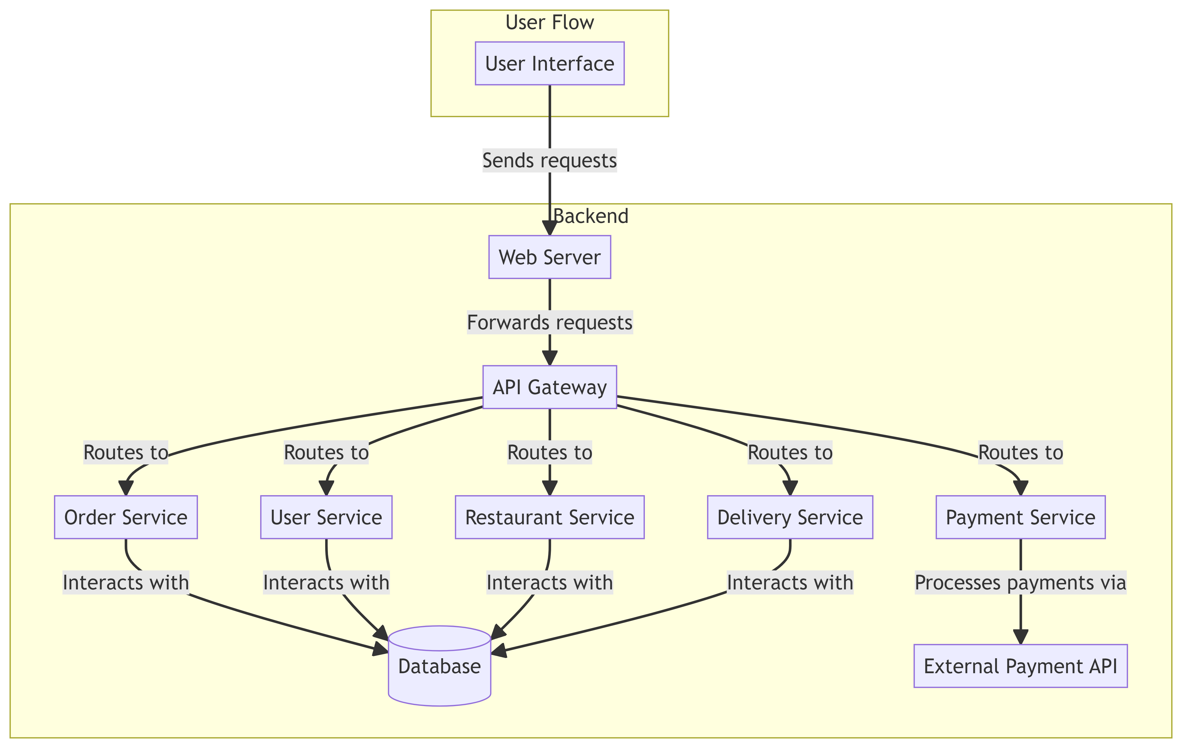

**Lab Session 3: Class Diagram**

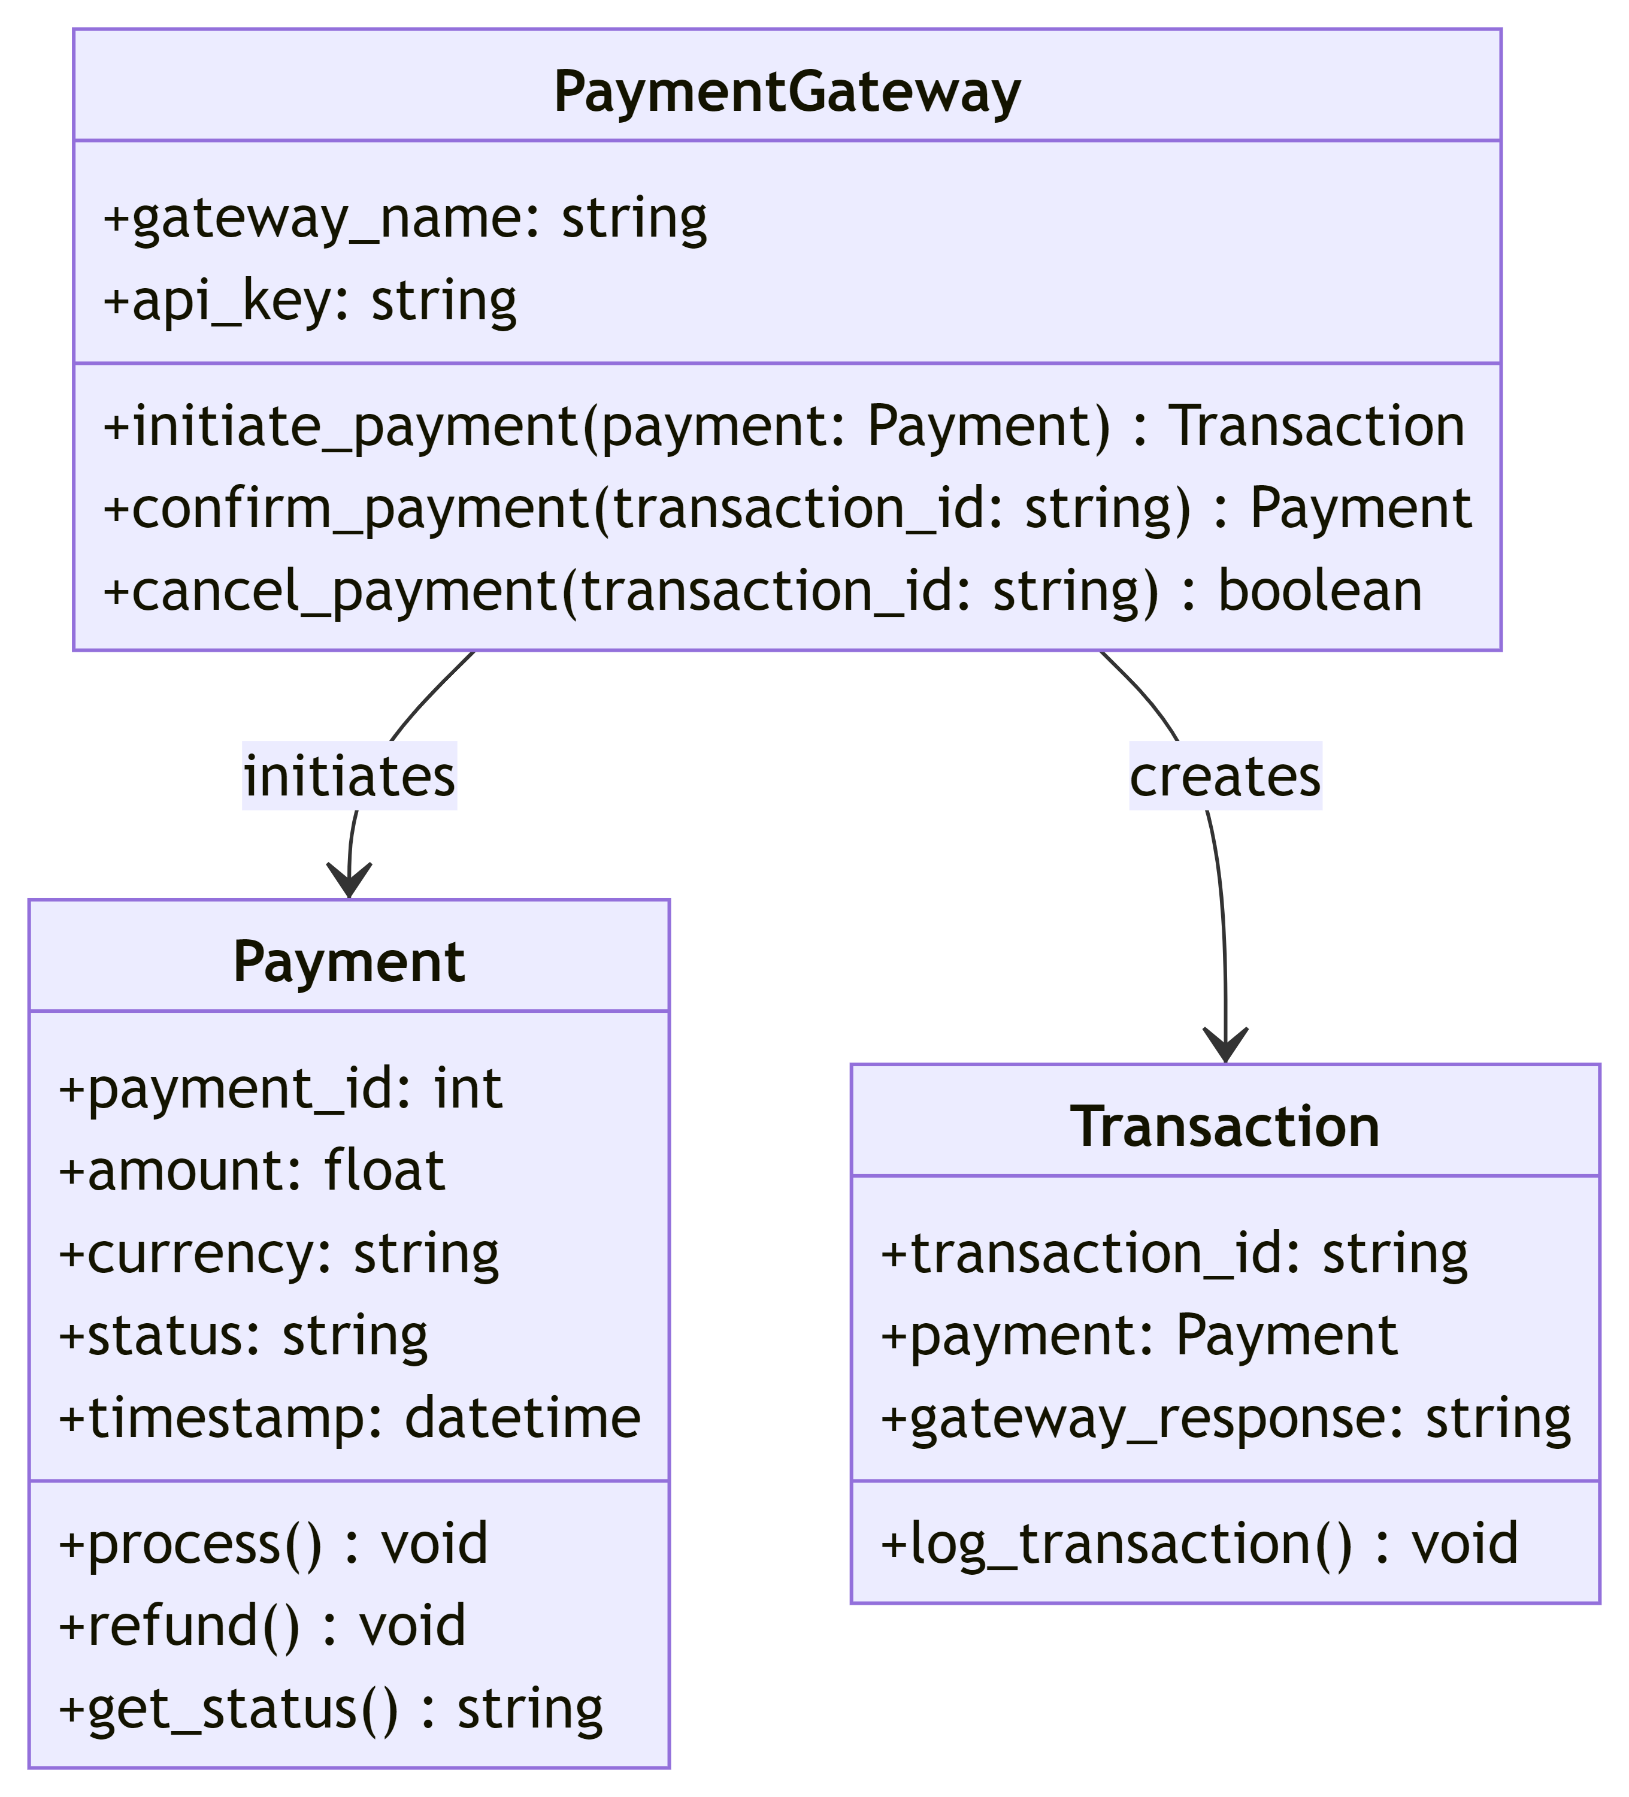

**Important Methods and Their Purpose**

* **Payment.process()**: Processes the payment and interacts with the payment gateway.
* **PaymentGateway.initiate_payment()**: Initiates a payment transaction with the payment gateway.
* **PaymentGateway.confirm_payment()**: Confirms if the payment was successful.
* **Transaction.log_transaction()**: Logs the transaction details for record-keeping.

**Sequence Diagram:**

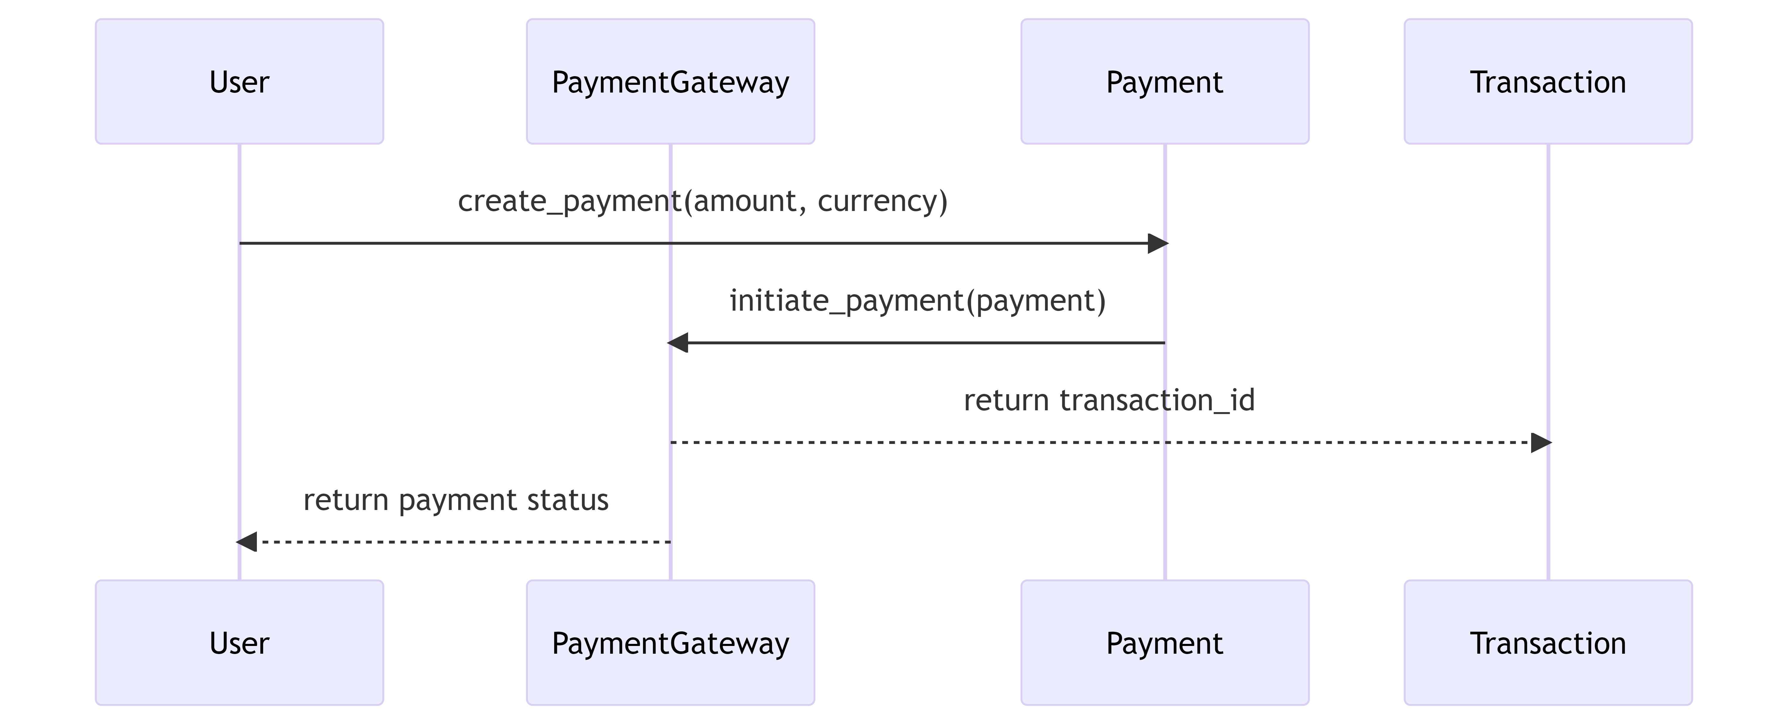

**API Endpoints for Payment Processing:**

**1. Initiate Payment**

* **Endpoint**: /api/payments/initiate
* **Method**: POST
* **Request Body**:

{

"amount": 100.00,

"currency": "USD",

"user_id": 12345

}

* **Response**:
  + **Success (201 Created)**:

{

"transaction_id": "abc123",

"status": "pending"

}

* + **Error (400 Bad Request)**:

{

"error": "Invalid payment details"

}

**2. Confirm Payment**

* **Endpoint**: /api/payments/confirm
* **Method**: POST
* **Request Body**:

{

"transaction_id": "abc123"

}

* **Response**:
  + **Success (200 OK)**:

{

"payment_id": 67890,

"status": "confirmed"

}

* + **Error (404 Not Found)**:

{

"error": "Transaction not found"

}

**3. Refund Payment**

* **Endpoint**: /api/payments/refund
* **Method**: POST
* **Request Body**:

{

"payment_id": 67890

}

* **Response**:
  + **Success (200 OK)**:

{

"payment_id": 67890,

"status": "refunded"

}

* + **Error (404 Not Found)**:

{

"error": "Payment not found"

}

**4. Get Payment Status**

* **Endpoint**: /api/payments/status
* **Method**: GET
* **Request Parameters**:
  + payment_id: 67890
* **Response**:
  + **Success (200 OK)**:

{

"payment_id": 67890,

"status": "confirmed",

"amount": 100.00,

"currency": "USD"

}

* + **Error (404 Not Found)**:

{

"error": "Payment not found"

}